Ideation Phase: Brainstorm & Idea Prioritization

Attribute | Details
- Date: 30 September 2026
- Team ID: SWTID-2026-3615
- Project Name: AI FAQ Assistant API
- Maximum Marks: 4 Marks

Page 1 | Step 1: Team Collaboration & Problem Definition

A. Team Setup & Session Objectives
- Session Duration: 10 mins prep + 50 mins active ideation
- Facilitation Tool: Digital Whiteboard (FigJam / Mural) with color-coded sticky notes
- Session Goal: Define friction points in automated query resolution and explore GenAI API solutions to automate accurate, contextual FAQ generation, active search, and document ingestion.
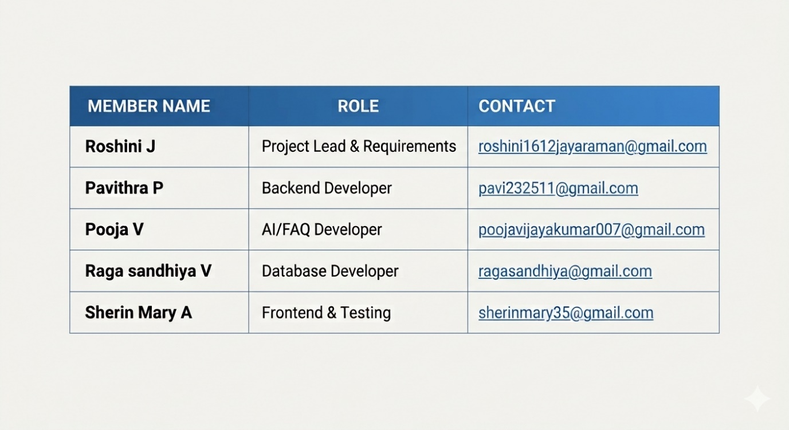

B. Problem Statement ("How Might We")

PROBLEM STATEMENT
"How might we empower users and organizations to transform dense, unstructured knowledge bases into active FAQ resolution systems— automated Q&As, contextual AI search, categorized tags, and dynamic responses—reliably and securely using modern Generative AI APIs?"

C. Core Ground Rules
- Focus on Topic: Center ideas on FAQ response accuracy, backend stability, latency, and API cost.
- Encourage Wild Ideas: Welcome ambitious features (e.g., auto-tagging, voice-enabled FAQ resolution, real-time analytics).
- Defer Judgment: Zero critique or elimination during the raw idea generation round.
- Build on Others: Connect teammates' technical inputs (e.g., pairing Multer uploads with Gemini prompts).
- Aim for Volume: Target 4–6 distinct sticky notes per participant.
- Stay Visual: Structure ideas with color categories, tags, and clear cards.

Page 2 | Step 2: Idea Listing & Thematic Grouping

A. Raw Idea Generation (Digital Sticky Notes)
Roshini J (Project Lead & Requirements):
- [R1] Decoupled Express MVC architecture for clear separation of routes, controllers, and services.
- [R2] Role-Based Access Control (RBAC) separating Admin, Editor, and End-User permissions.
- [R3] Requirements mapping for auto-generating categorized Q&A pairs from uploaded raw documents.
- [R4] JWT authentication with dual access and refresh token lifecycle.
Pavithra P (Backend Developer):
- [P1] Multipart file upload handler (Multer) to ingest and parse .txt and .md knowledge base files.
- [P2] Secure environment key management (.env) for database credentials and Gemini API keys.
- [P3] Middleware rate-limiting on query endpoints to prevent quota exhaustion and abuse.
- [P4] Markdown and JSON sanitizer filter to strip ```json code artifacts before database storage.
Pooja V (AI/FAQ Developer):
- [PJ1] Google Gemini 1.5 Flash integration for ultra-fast, low-latency Q&A generation.
- [PJ2] Structured prompt pipeline converting raw documentation into bulleted FAQ summaries.
- [PJ3] JSON-mode prompt returning structured Q&A arrays [{ question, answer, category, tags }].
- [PJ4] Dynamic AI Search Assistant route providing contextual, high-confidence answers to raw user questions.
Raga sandhiya V (Database Developer):
- [RS1] Modular Mongoose schemas for User, KnowledgeBase, FAQ, Category, and QueryLog.
- [RS2] Cascading delete logic: purging a knowledge base automatically removes child FAQ entries.
- [RS3] Response result caching in MongoDB to avoid duplicate Gemini API calls for identical documents.
- [RS4] Category and tag-based indexing in MongoDB for rapid query filtering and lookup.
Sherin Mary (Frontend & Testing):
- [SM1] Postman automated assertion test collection verifying status codes and FAQ schema payloads.
- [SM2] Simple UI component layout for uploading knowledge bases and searching generated FAQs.
- [SM3] Input validation middleware for query string length and payload structure verification.
- [SM4] Export utility enabling users to download generated FAQs as JSON or CSV files.

B. Thematic Clustering (4 Functional Domains)
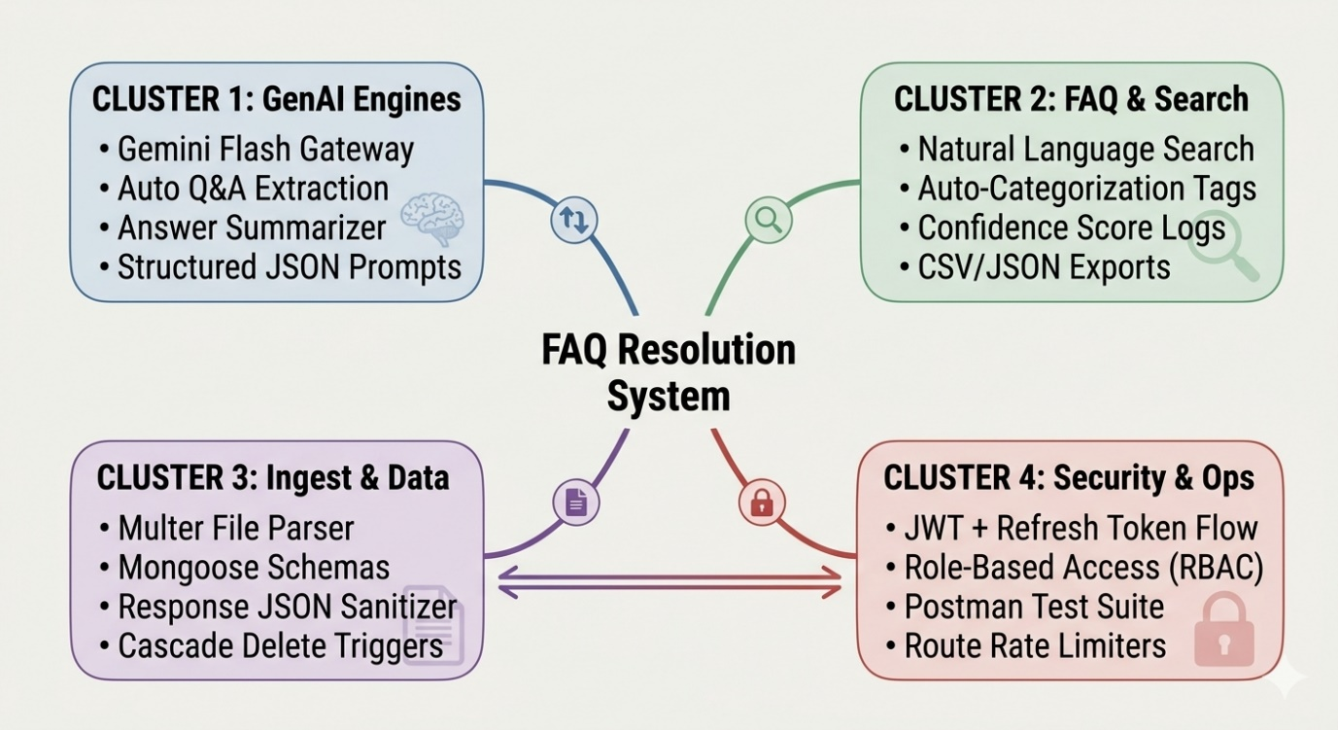

Page 3 | Step 3: Prioritization & Final MVP Scope

A. Feasibility vs. Importance Matrix
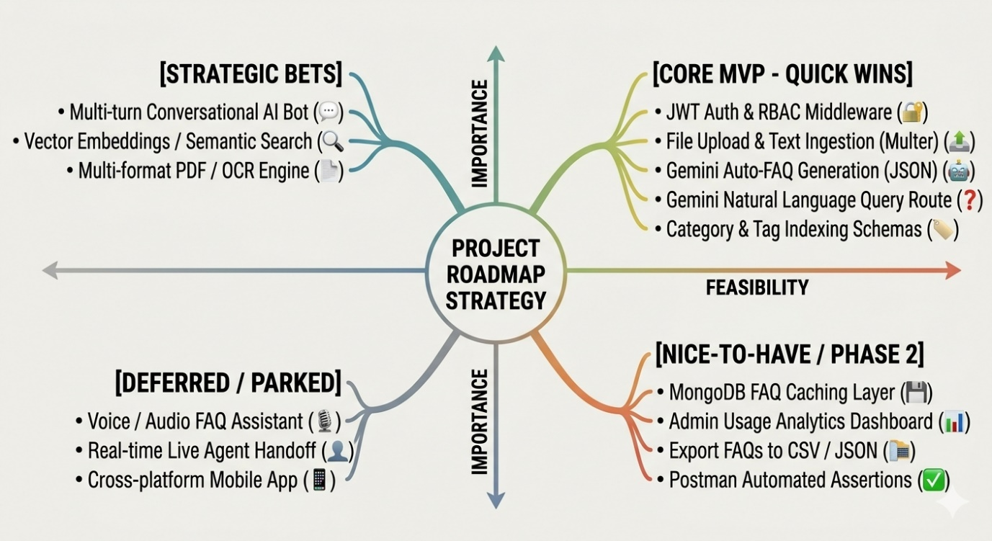

B. Decision Matrix Table
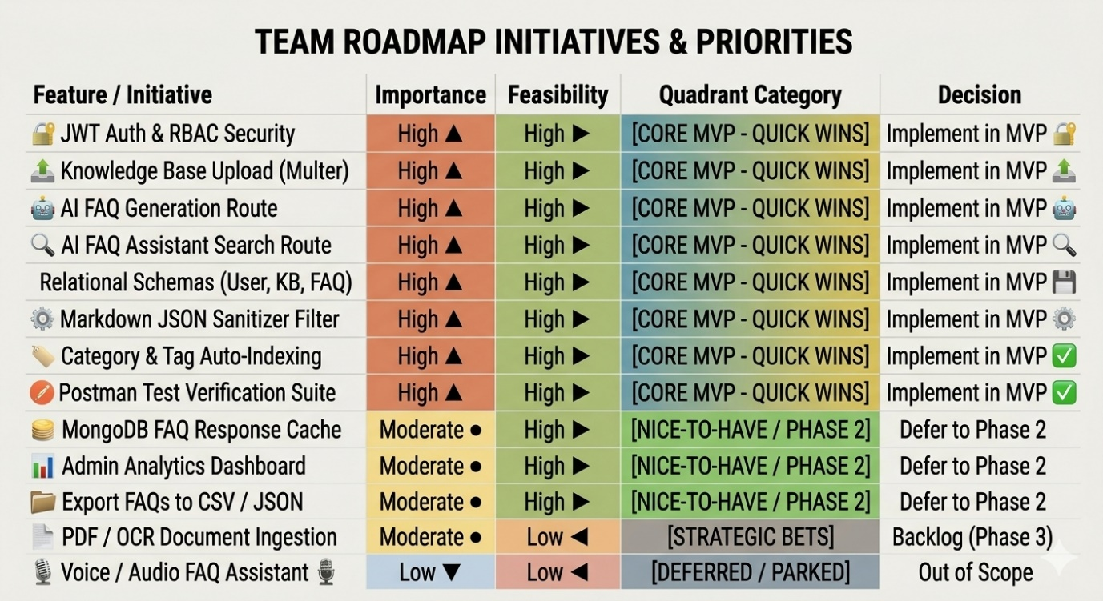

C. Final MVP Scope & Execution Endpoints
- Auth Service:
  - POST /api/auth/register — Register User, Editor, or Admin profiles.
  - POST /api/auth/login — Authenticate and issue access/refresh JWTs.
- Ingestion Service:
  - POST /api/knowledge-base/upload — Multipart text/markdown parser via Multer.
- AI FAQ & Search Generation Routes:
  - POST /api/faqs/generate/:kbId — Auto-generates structured [{ question, answer, category, tags }] arrays.
  - POST /api/faqs/ask — Receives natural language queries and returns contextual AI-driven answers.
  - GET /api/faqs — Retrieves categorized, indexed FAQ lists with pagination.
- Data Integrity & Security:
  - JSON sanitization utility stripping ```json code artifacts prior to database persistence.
  - Rate-limiting middleware on AI routes to enforce quota stability.

